Problem 1:

1. g
2. h
3. f
4. a
5. c
6. e

Problem 2:

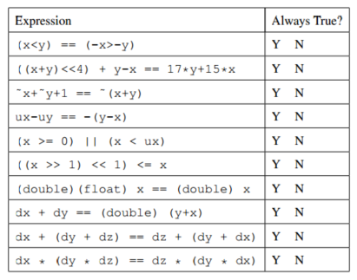

Problem 3:

|  |  |  |
| --- | --- | --- |
| Number | Decimal Representation | Binary Representation |
| Zero | 0 | 000000 |
| n/a | -1 | 111111 |
| n/a | 17 | 000101 |
| n/a | -11 | 110110 |
| n/a | 26 | 01 1010 |
| n/a | -26 | 10 0110 |
| TMax | 31 | 011111 |
| TMin | -32 | 100000 |
| TMax+TMax | -2 | 111110 |
| TMin+TMin | 0 | 000000 |
| TMin+1 | -31 | 100001 |
| TMin−1 | 31 | 011111 |
| TMax+1 | -32 | 100000 |
| −TMax | -31 | 100001 |
| −TMin | -32 | 100000 |

Problem 4:

(2.87 p. 137)

|  |  |  |  |  |  |
| --- | --- | --- | --- | --- | --- |
| Description | Hex | M | E | V | D |
| -0 | 8000 | 0 | -62 | -0 | -0.0 |
| Smallest value > 2 | 4001 | 257/256 | 1 | 257/128 | 2.0 |
| 512 | 4800 | 1 | 72 | 512 | 512.0 |
| Largest denormalized | 00FF | 255/256 | -62 | 255x2-70 | 255 |
| -∞ | FF00 |  |  | -∞ | -∞ |
| Number with hex representation 3BB0 | 3BB0 | 27/16 | -4 | 27/256 | 15280 |

Problem 5:

(2.88 p.138)

|  |  |  |  |
| --- | --- | --- | --- |
| Format A | | Format B | |
| Bits | Value | Bits | Value |
| 1 01111 001 | -9/8 | 1 0111 0010 | -9/8 |
| 0 10110 011 | 176 | 0 1110 0110 | 176 |
| 1 00111 010 | -5/1024 | 1 0000 0101 | -5/1024 |
| 0 00000 111 | 7/131072 | 0 0000 0001 | 1/1024 |
| 1 11100 000 | -8192 | 1 1110 1111 | -248 |
| 0 10111 100 | 384 | 0 1111 0000 | +∞ |

Problem 6:

(2.90 p.139)

float fpwr2(int x){

if(x<**-149**){

exp = **0**;

frac = **0**;

} else if (x < **-126**){

exp = **1;**

frac = **1<<(x+149);**

} else if (x < **128**){

exp = **x + 127**;

frac = **0**;

} else {

exp = **255**;

frac = **0**;

}

}